**SQL Practice**

**Week 1 – Day 1**

**What does SQL stand for?**

**Our client needs to know:**

1. **An alphabetical list of customers located in Mexico**

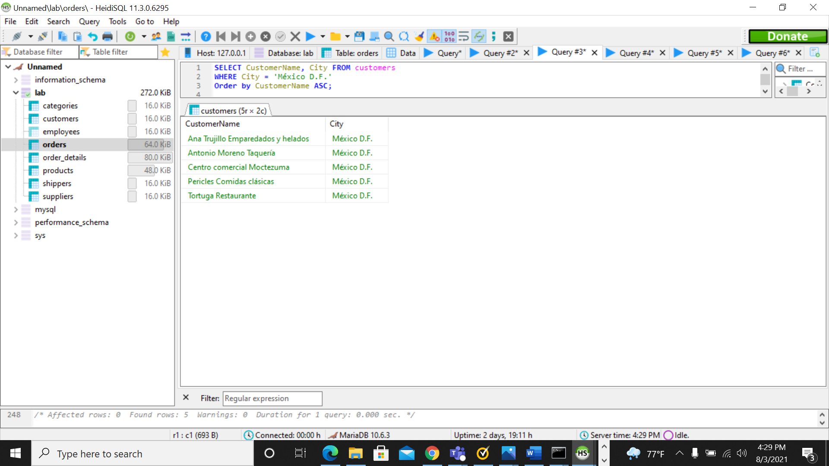

1. **A list of employees from youngest to oldest**

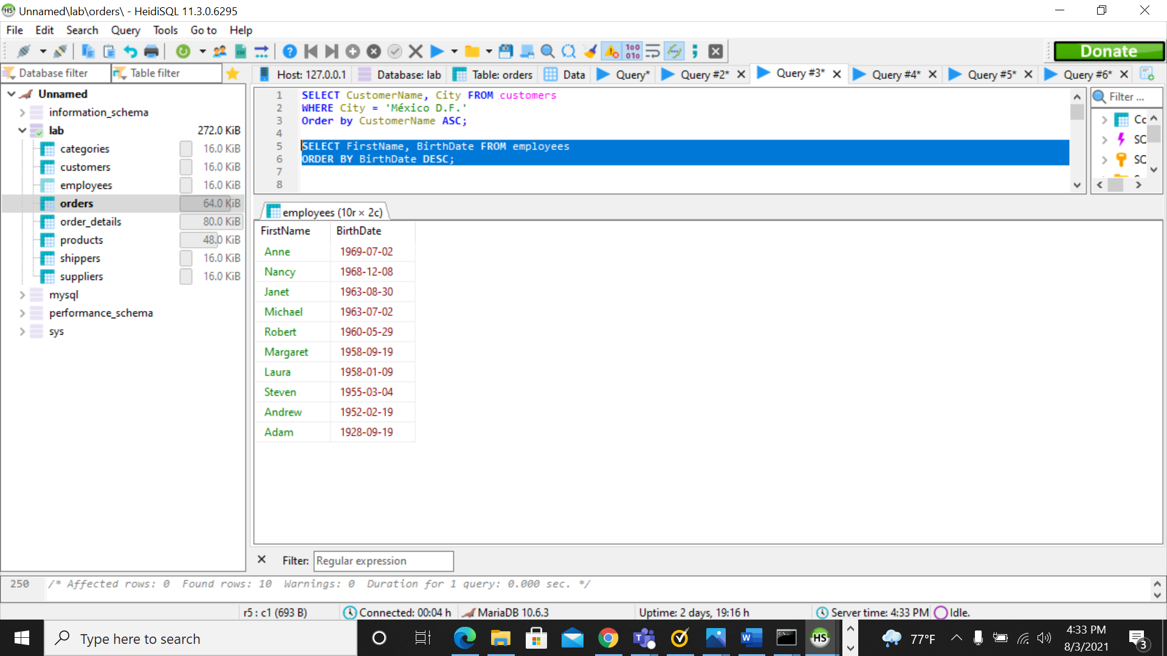

1. **A list of orders that included “Dairy Products” and “Grains/Cereals”**

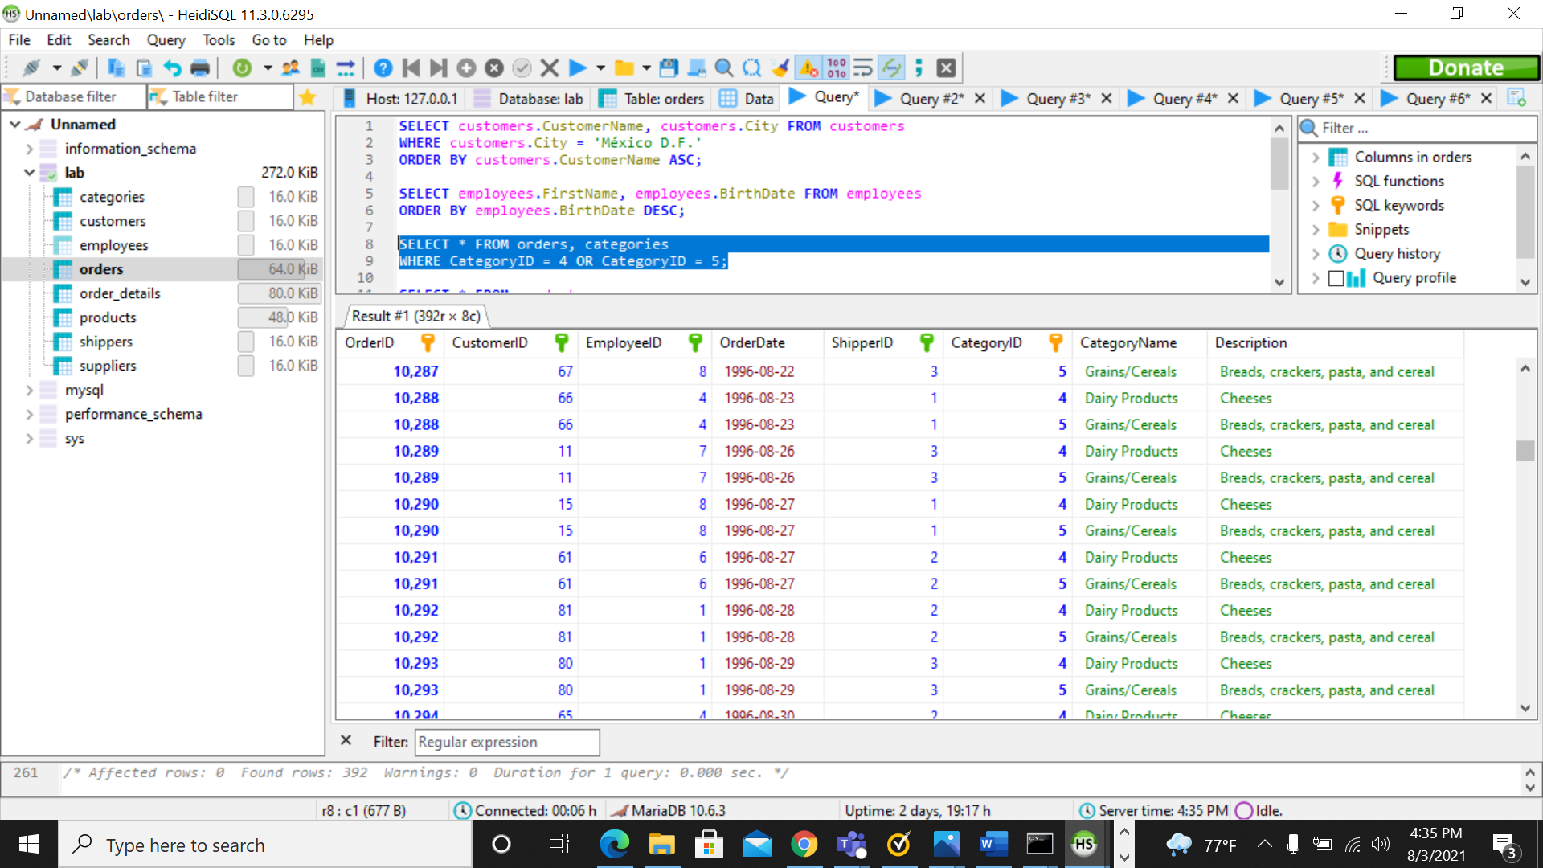

1. **What products are supplied by “G'day, Mate” ?**

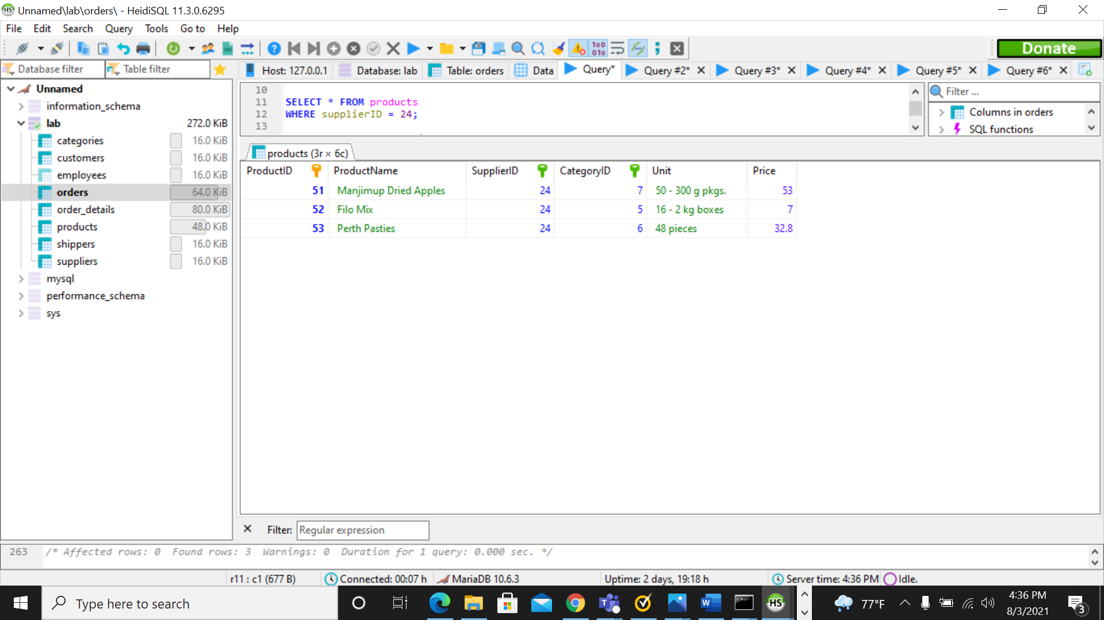

1. **What shippers have delivered our orders per country?**

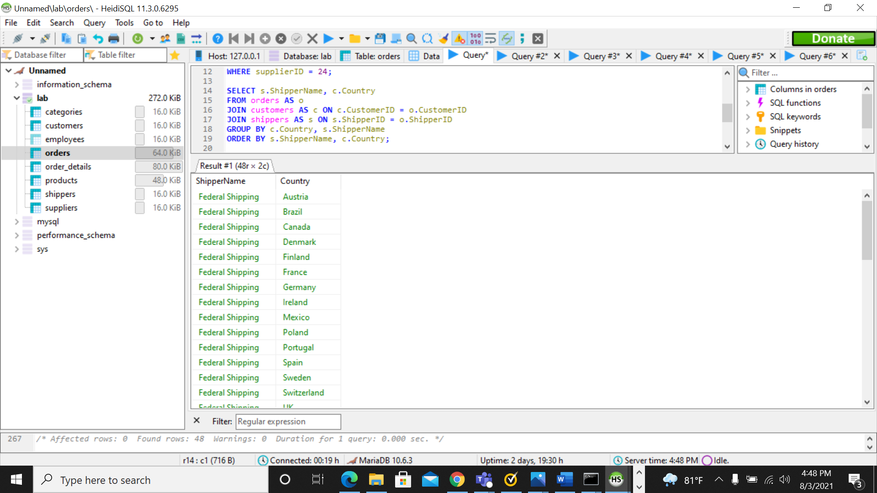

1. **The list of orders managed by Nancy Davolio during 1997**

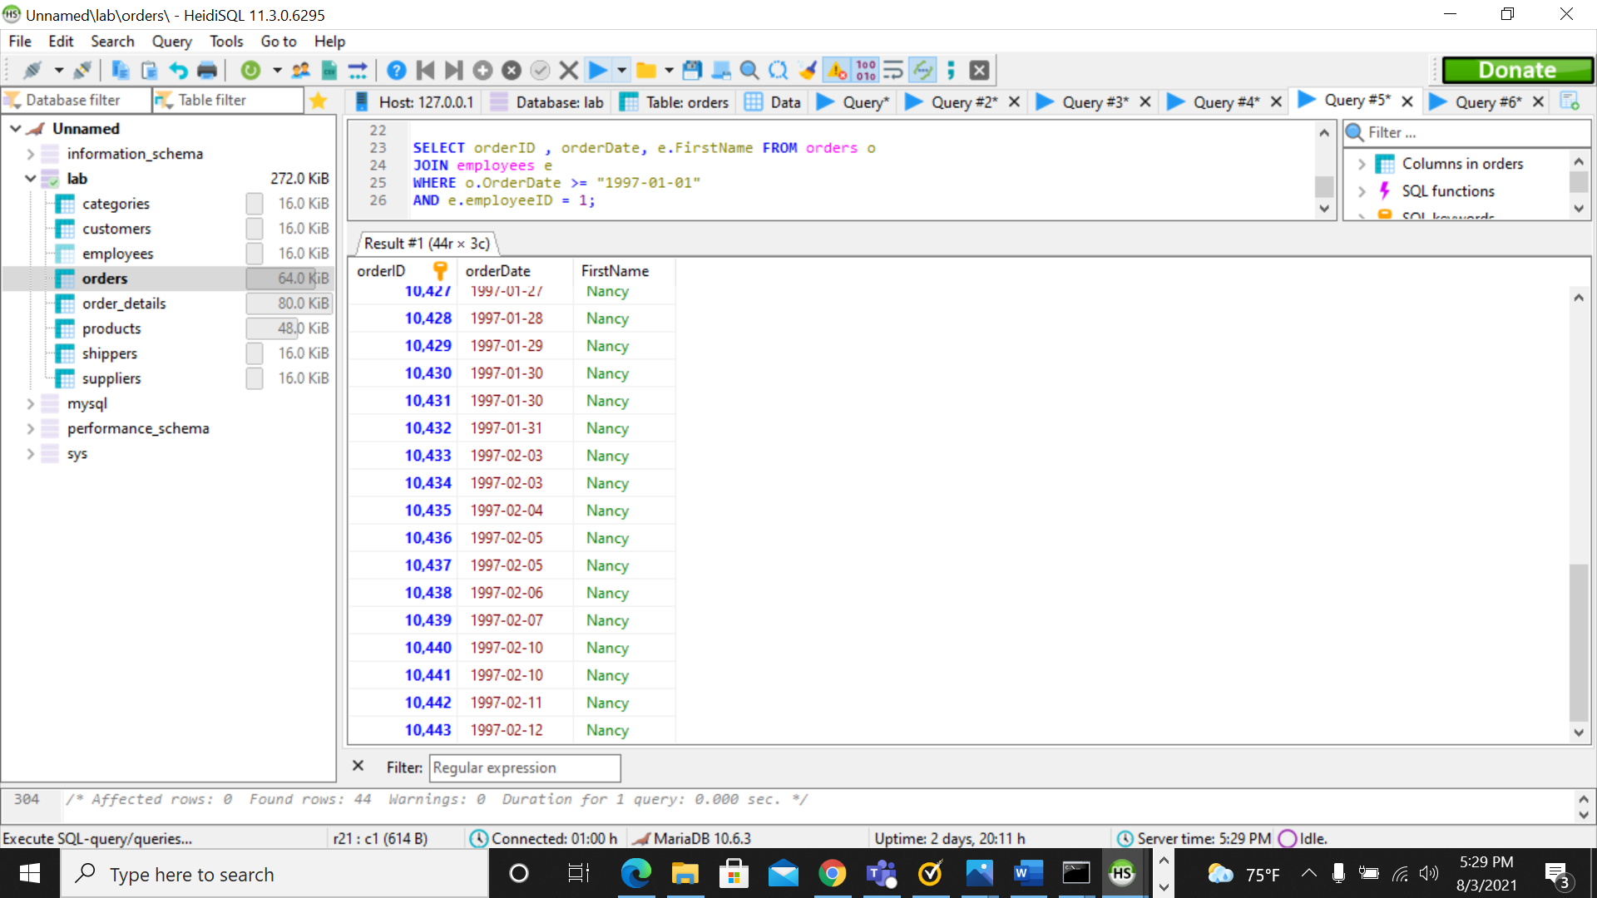

**SQL Practice**

**Week 1 – Day 2**

**Our client needs to know:**

1. **A list of our US suppliers, identifying their phone area code.**

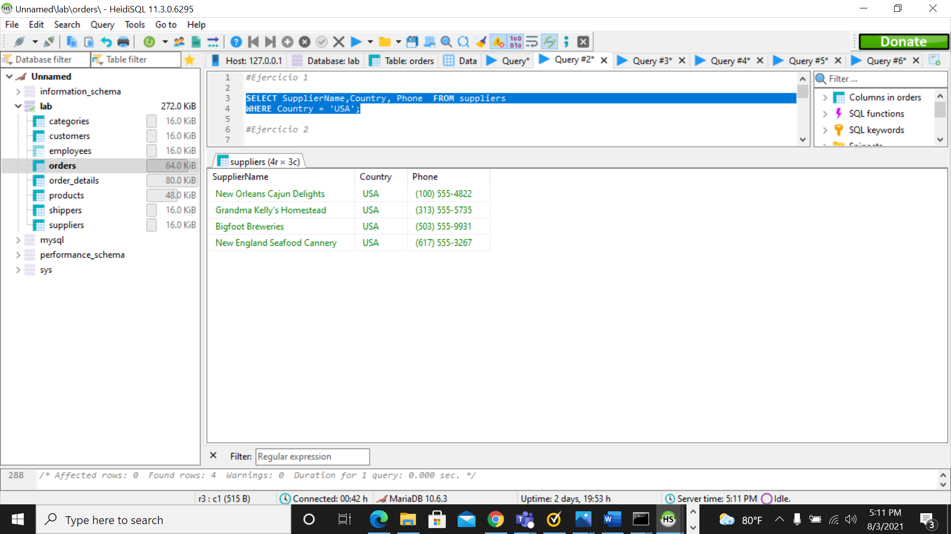

1. **What customer(s) have never placed an order?**

**3. In what countries do we have customers?**

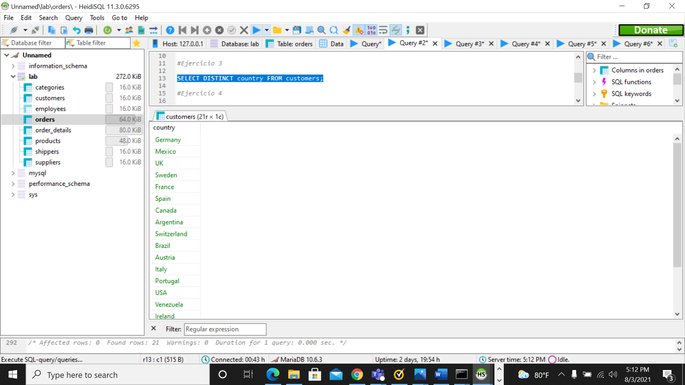

**4. What are the 5 most sold products?**

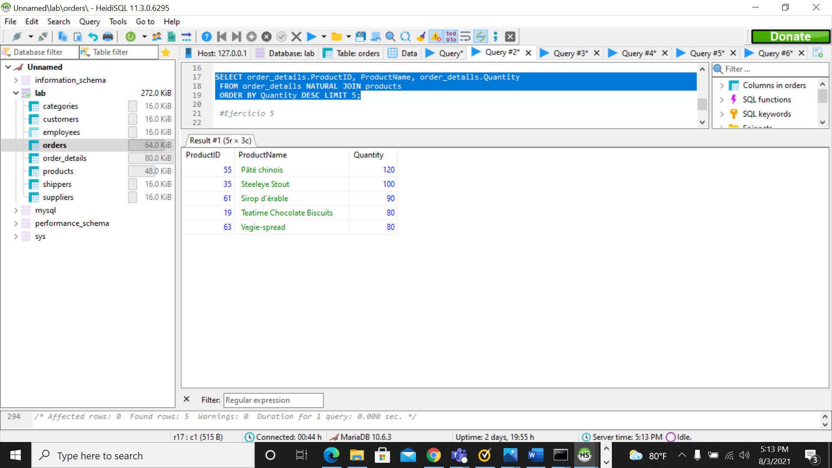

**5. What product(s) should our client stop offering?**

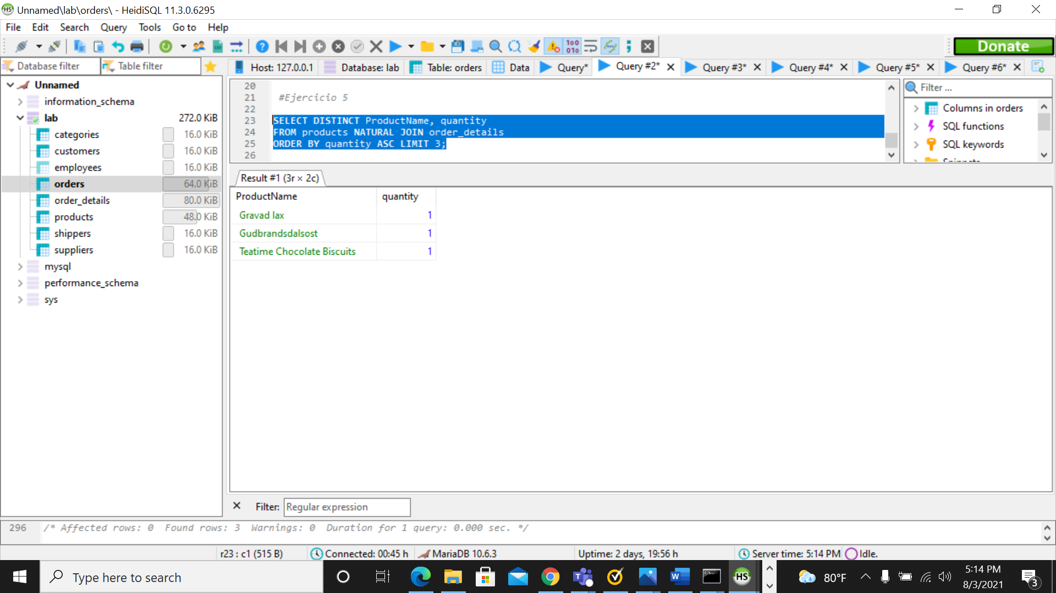

**SQL Practice**

**Week 1 – Day 3**

Our client needs to know:

1. What products do we sell the most of and how much do we charge for them?

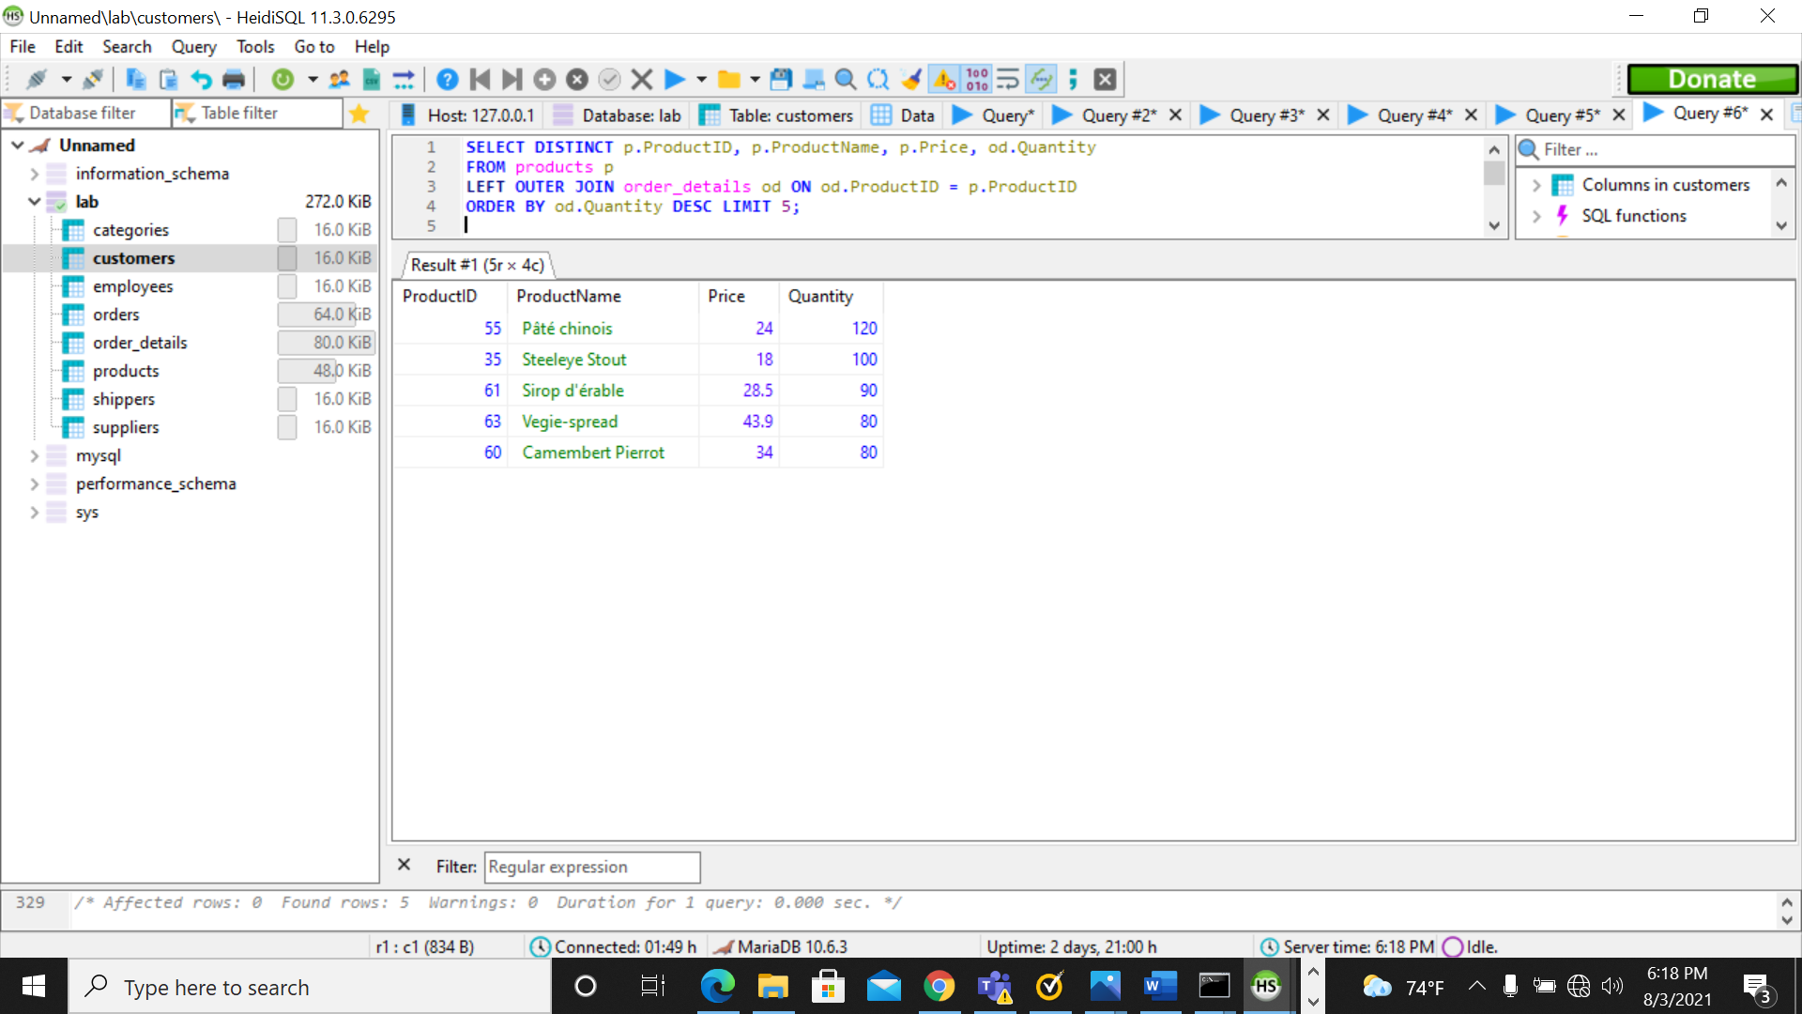

1. Which products brings us the most revenue? (Excluding “Alice Mutton” because they are going out of business.)

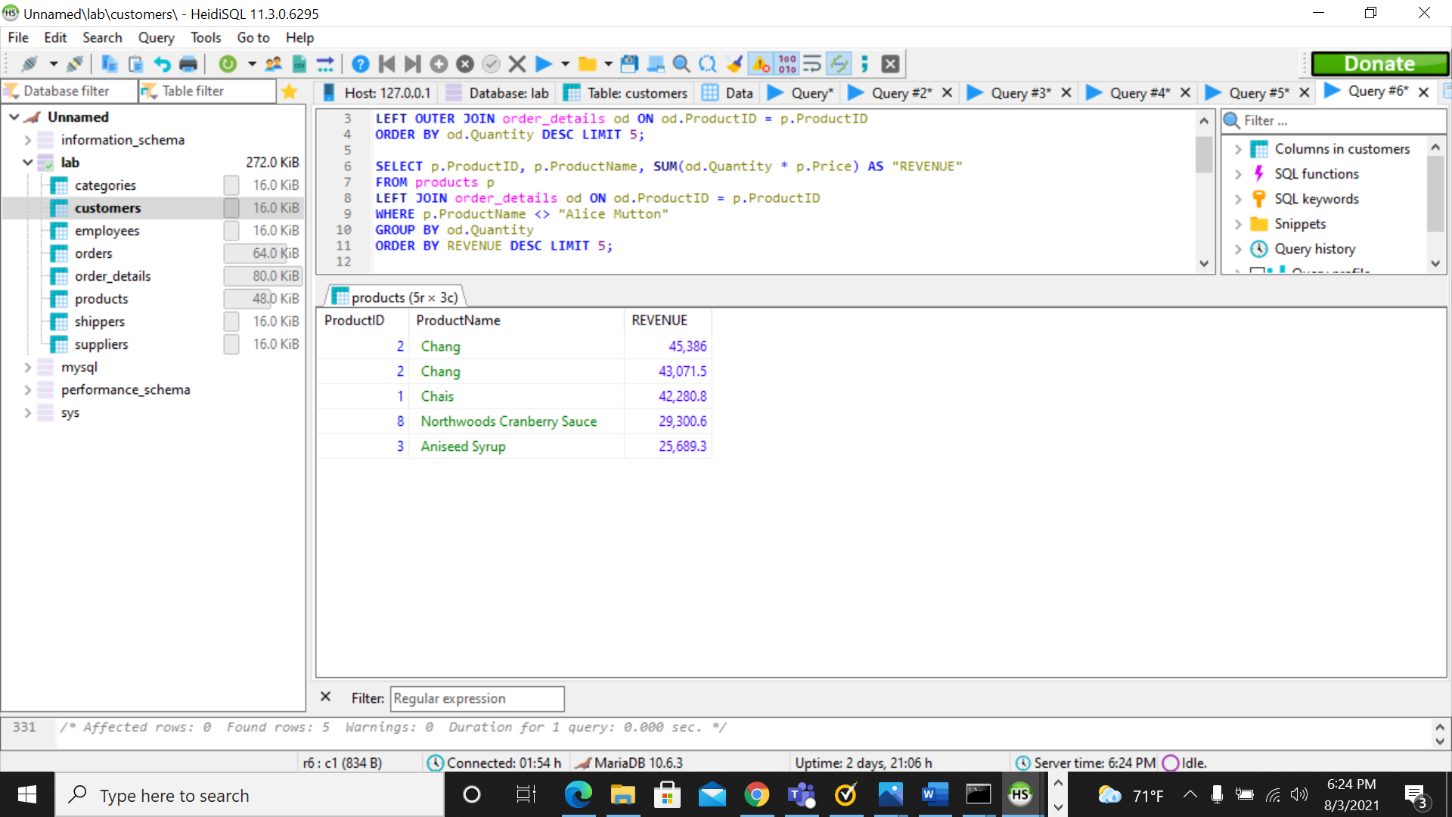

1. What is our Annual Total Revenue?

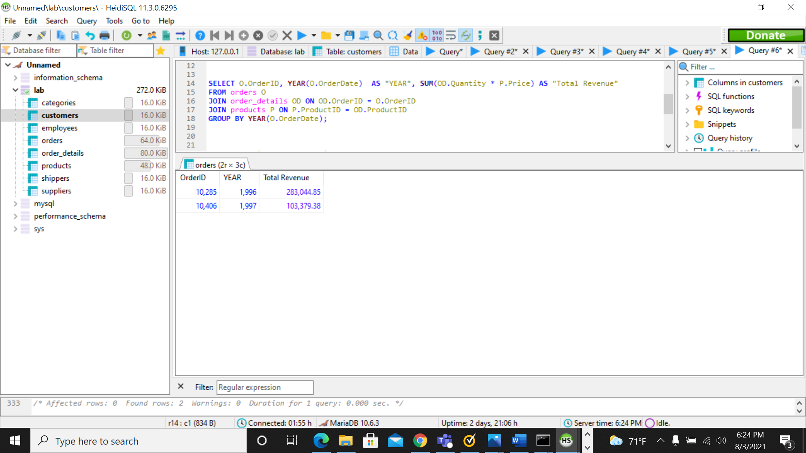

1. Who is the shipper that delivers most of our customers' orders?

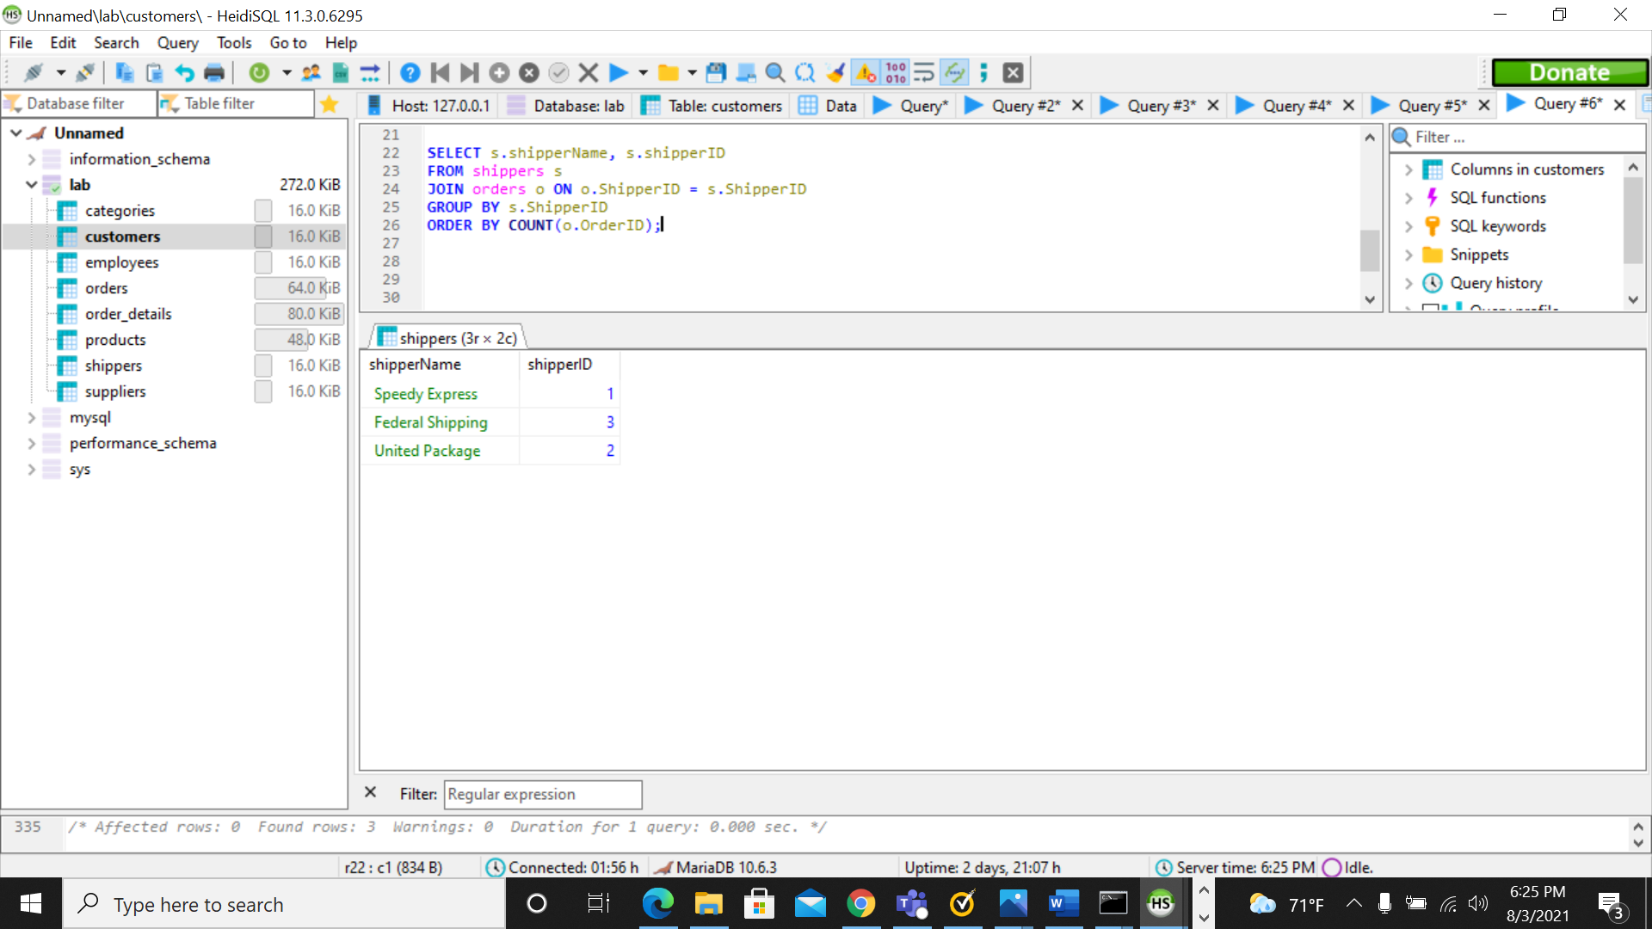

1. Do we have customers that only request orders for one category of products?